 Kids Menu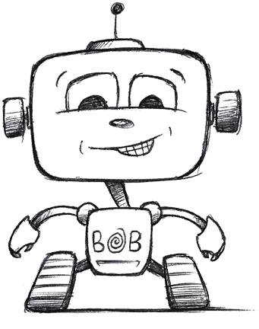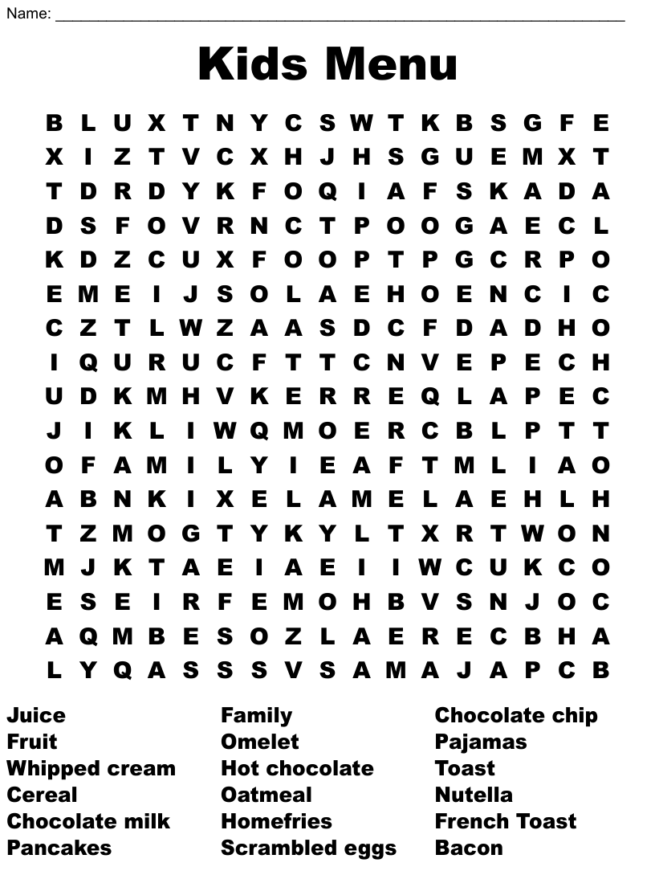

Beef Burger £7.00

Cheese Burger £7.50

Southern Fried Chicken Goujons £7.00

Battered Cod £8.00

Sausages £7.00

Veggie Sausages (VE) £7.00

**All above with a choice of fries or mash & peas or beans**

Bolognese Linguine £7.00

Mac ‘n’ Cheese (V) £7.00

DESSERTS

Brownie Sundae £4.00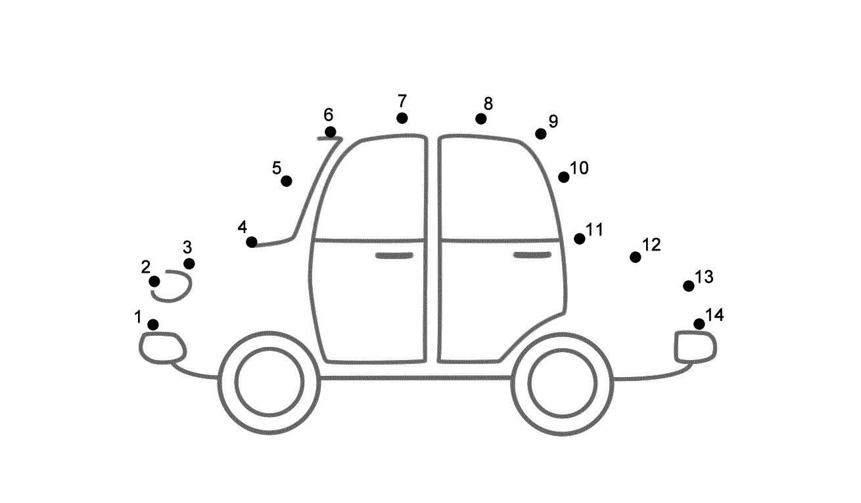

Ice Cream £3.50

**2 Scoops of vanilla Ice Cream, with a choice of chocolate or strawberry sauce**

Jelly & Vanilla Ice Cream £4.00

meal deal

Any Kids Main, Dessert & Drink for just £10

*Fruit shoot, squash or small coke, diet coke or lemonade